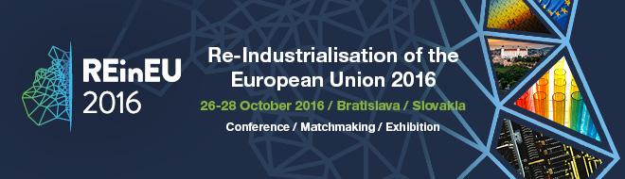
Dear Madame, Dear Sir,
We are honoured to invite you to the international conference “Re-Industrialisation of the European Union” – www.reineu2016.eu , one of the largest events associated with the Slovak presidency of the Council of the European Union taking place in Bratislava, Slovakia on 26-28 October 2016. Please find attached the official invitation.

The new technologies and materials represent essential inputs for any industrial activity and many industrial sectors will undergo a transformational change to high tech, by digitisation of processes and provided services. Human resources will need to be trained and motivated appropriately for this change and the existing workforce will be retrained. The resources utilisation will be fully optimised and byproducts will be transformed to valuable raw materials. The conference aim is to present trends, opportunities and success cases as well as policy recommendations for barrier removal.

You can find more information about the event and the registration on the website, or contact the organisers directly at reineu2016@cvtisr.sk for more possibilities to promote your institution/company (booth, poster, extra workshop, etc.)
Looking forward to meet you in Bratislava.
